Knowledge Activity: Classification and Terminology Systems (Master’s)

Learning objectives
- Apply diagnosis/procedure codes according to current guidelines (3)
- Identify the functions and relationships between healthcare classification systems (3)
- Analyze current regulations and established guidelines in clinical classification systems (4)
- Map terminologies, vocabularies and classification systems (4)
- Evaluate the accuracy of diagnostic and procedural coding (5)
- Evaluate, implement and manage electronic applications/systems for clinical classification and coding (5)
- Evaluate the accuracy of diagnostic and procedural coding (5)
- Interpret terminologies, vocabularies and classification systems (5)
- Construct and maintain processes, policies, and procedures to ensure the accuracy of coded data based on established guidelines (6)
- Construct examples of mapping of clinical vocabularies and terminologies to appropriate classification systems (6)

Student instructions
- If you have questions about this activity, please contact your instructor for assistance.
- You will review the chart of Zain Hamdan to complete this activity. Your instructor has provided you with a link to the Classification and Terminology Systems (MS) activity. Click on 2: Launch EHR to review the patient chart and begin this activity.
- Refer to the patient chart and any suggested resources to complete this activity.
- Document your answers directly on this activity document as you complete the activity. When you are finished, you will save this activity document to your device and upload this activity document with your answers to your Learning Management System (LMS).

Glossary
Classification system: a system “that arranges or organizes like or related entities.” (Giannangelo, 2014). A classification system is used to classify clinical procedures and conditions, enabling statistical data across the national and international healthcare systems. Classification systems have other applications in healthcare, including research, performance monitoring, reimbursement, public health reporting and quality of care assessment. (Alakrawi, 2016).
Some common classification systems (World Health Organization, 2016):
- International Classification of Diseases, 9th revision, Clinical Modification (ICD-9-CM): Coding system used to classify and code diagnoses and procedures. Was used in the United States until September 30, 2015.
- International Statistical Classification of Diseases and Related Health Problems, 10th revision (ICD-10): Classification system used for systematic recording, analysis, interpretation, and comparison of mortality and morbidity data from different countries and to translate diagnoses, diseases and other conditions into codes. Implemented as the standard coding system for classifying diseases and related health problems in the United States on October 1, 2015. Implementation in Canada as ICD-10-CA began in 2001.
- International Classification of Diseases, 10th revision, Clinical Modification (ICD-10-CM): Coding system used to report diseases and conditions of US healthcare patients.
- International Classification of Diseases, 10th revision, Procedure Coding System (ICD-10-PCS): Coding system developed to replace Volume 3 of the ICD-9-CM manual.
- Current Procedural Terminology (CPT): Coding system established by the American Medical Association for coding of procedures and services.
Terminology system: a system characterized by “a set of concepts and relationships that provide a common reference point for comparisons and aggregation of data about the entire health care process, recorded by multiple different individuals, systems, or institutions.” (Imel, M. & Campbell, J., 2003).
One of the most common terminology systems is the Systematized Nomenclature of Medicine - Clinical Terms (SNOMED CT).
- SNOMED CT: a controlled, multilingual medical terminology system that healthcare providers use for the electronic exchange of clinical health information, which provides structured terminology to enable coding of an entire medical record. (Imel, M. & Campbell, J., 2003).

The activity
EHR Go is an educational EHR used for educational purposes only and does not contain 100 percent of classification codes that might be found in an EHR in practice. EHR Go has ICD-9, ICD-10 and CPT codes, but does not have SNOMED CT.

Differences between ICD-9 and ICD-10

There are significant differences between ICD-9 and ICD-10 codes. There are nearly 19 times as many procedure codes and nearly 5 times as many diagnosis codes in ICD-10-CM than in ICD-9-CM. Further, ICD-10 uses alphanumeric categories instead of simple numeric categories like ICD-9 does. (CDC, n.d.-b).
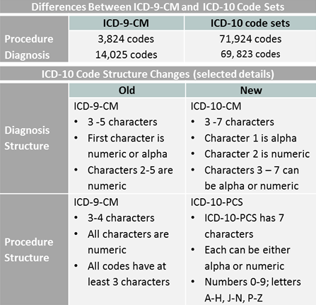
The ICD-10 codes include an expanded number of characters, which allows for greater specificity to identify disease etiology, anatomic site and severity.
ICD-10 Code Structure:
- Characters 1-3 – Category
- Characters 4-6 – Etiology, anatomic site, severity, or other clinical detail
- Character 7 – Extension

Character 7 for ICD-10 indicates:

A – Initial encounter
D – Subsequent encounter
S – Sequela
(Mitchell, D., 2014).

- Initial encounter: Patient’s initial encounter for active treatment of an injury. (CDC, n.d.-a)
Example: A patient is seen in the Emergency Department for a displaced transverse fracture of the left ulna. The ED applies ice and immobilization, but the fracture cannot be managed immediately. Instead, the ED advises the patient to seek follow-up with an orthopedic specialist. This ED encounter would be reported using S52.222A Displaced transverse fracture of the left ulna, initial encounter for closed fracture. (Mitchell, D., 2014).
Should the patient see an orthopedist the next day, and the orthopedist is able to reduce the fracture, this would be considered initial active treatment for the fracture. Because the ED was only able to provide comfort care, the encounter with the orthopedist would be considered the first encounter of definitive care. Therefore, this encounter would also be considered an initial encounter and S52.222A code would again be used. (Mitchell, D., 2014).
- Subsequent encounter: “Encounters after the patient has received active treatment of the injury and is receiving routine care for the injury during the healing or recovery phase.” (CDC, n.d.-a)
“Examples of subsequent care are: cast change or removal, removal of external or internal fixation device, medication adjustment and follow up visits following injury treatment.” (CDC, n.d.-a)
- Sequela: “for use for complications or conditions that arise as a direct result of an injury, such as scar formation after a burn. The scars are sequelae of the burn.” In other words, sequela are the late effects of an injury. (CDC, n.d.-a)

Introducing SNOMED CT
SNOMED CT is a standard clinical terminology system with specific support for multi-lingual translation. SNOMED CT can cross-map to other international standards and classifications. (Alakrawi, 2016). For example:

SNOMED CT to ICD-9-CM Reimbursement Map
SNOMED CT to ICD-10-CM Map
ICD-9-CM Diagnostic Codes to SNOMED CT Map
ICD-9-CM Procedure Codes to SNOMED CT Map

Knowing how to cross-map the coding systems is important for data collection, retaining the value of the data when going from one database to another, limiting or preventing errors, and controlling costs. U.S. National Library of Medicine. (n.d.).

Differences between SNOMED CT and ICD-10
- SNOMED CT coding is completely automated by the system, while ICD-10 coding is usually performed manually by professional coders. Although coders may utilize computer-assisted coding (CAC), human intervention is still required to validate the coding.
- SNOMED CT has more specific clinical coverage than ICD-10, with 100,000 coding concepts in SNOMED CT compared to 68,000 ICD-10 diagnosis codes. As a result, more than one ICD-10 code may be needed to represent one concept in SNOMED CT.
- SNOMED CT is more clinician friendly. ICD-10 codes often include conventions used by coders (e.g. initial encounter, subsequent encounter, sequela, etc.) that are irrelevant and confusing for clinicians.
- ICD-10 is utilized by a wider spectrum of healthcare users and, unlike SNOMED CT, can help provide patients with information on treatment options, costs and outcomes.
- ICD-10 provides a much simpler system for the collection and reporting of data for research, which, in turn, benefits consumers through improved reimbursement systems, surveillance of public health and monitoring of administrative performance.
(Alakrawi, 2016).

EHR Go and SNOMED CT
There is not SNOMED-CT or a mapping system between ICD-9 and ICD-10 terms and codes in the EHR Go EHR. Users must select the appropriate codes manually. On the Problems tab of the patient chart, after choosing the New button in the bottom right corner, users have the option to search for and define problems using ICD-9, ICD-10, or a free-text “Add Other” option.
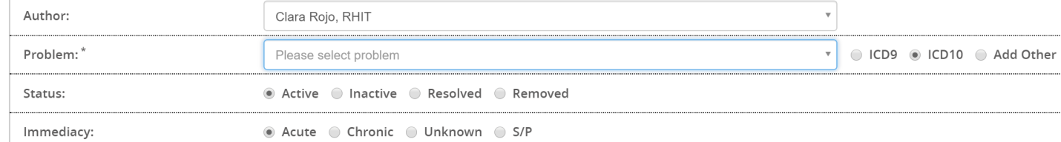
Assigning an ICD-10 diagnosis code or a CPT procedure code for billing purposes can be done from the Account section of the chart under the Claims tab.

To add a diagnosis code, users can click on the Add Diagnosis button under the Diagnosis or Nature of Illness or Injury section of the Account/Claims tab.
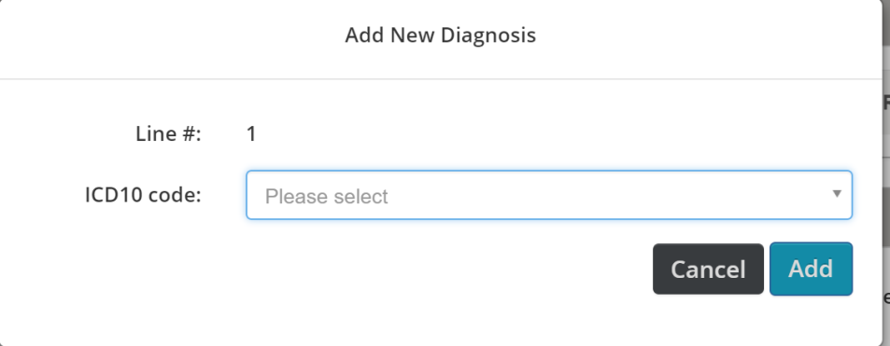
To add a procedure code, users can click on the Add Procedure button under the Procedure/Service/Supplies section of the Account/Claims tab.
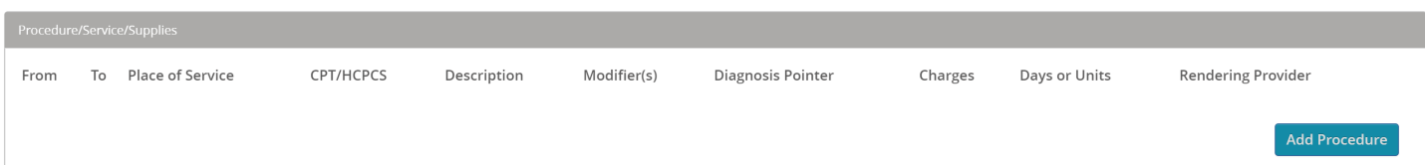
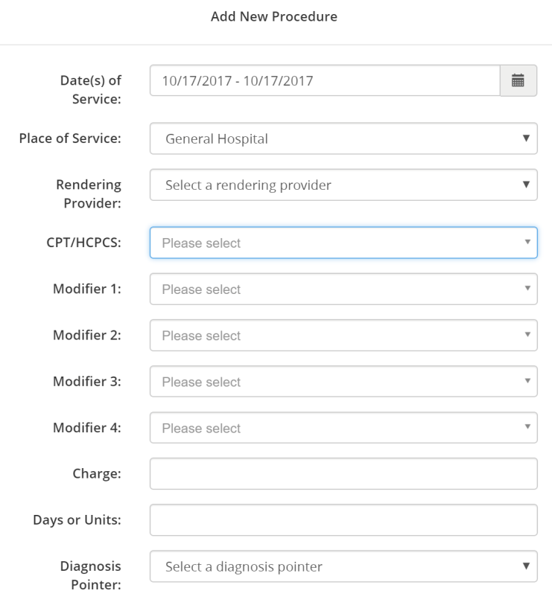

Apply your knowledge

Open the EHR for patient Zain Hamdan. Utilizing the information found in the patient’s chart and the information provided above, answer the questions below.

Questions
Zain’s back pain has recently worsened because of a fall, and his problem of chronic pain needs to be added to the problem list in his chart. Click on the Problems tab in Zain’s EHR. Click on New in the bottom right corner. Look up the ICD-9 code for Chronic pain due to trauma by selecting the ICD-9 option to the right of the Problem field and performing a search as outlined above on page 5.

- What is the ICD-9 code for Chronic pain due to trauma? 338.21
- Next, search for the ICD-10 code for Chronic pain due to trauma. What is the ICD-10 code? G89.21
- Close out of the Problem Edit screen by clicking Cancel. Choose Don’t Save. Zain has a problem of Primary pulmonary hypertension in his chart that is classified with an ICD-9 code. What is the ICD-9 code? 416.0
- If the ICD-9 code for Primary pulmonary hypertension were updated to an ICD-10 code in the chart, what would the ICD-10 code be? I27.0 (“i”)
- Zain has a problem entered in his chart for gastro-esophageal reflux disease that is not coded using an ICD code. If an ICD-10 code needed to be assigned to this problem, what additional information would be helpful to know regarding Zain’s gastro-esophageal reflux disease? With esophagitis versus without espophagitis
- Spelling is important when searching for ICD codes. If a user was searching for an ICD-10 code for “gastroesophageal” or GERD (instead of gastro-esophageal”), what would they discover? What does this tell you about search protocol for ICD codes? They would discover there is no match, this shows that spelling and punctuation such as hyphenation are important.
- To better understand the differences between ICD-9s and ICD-10s, assume that Zain was also suffering from a dog bite. Perform another search on the Problem tab. Search for “dog” under both ICD-9 and ICD-10. List all ICD-9 and ICD-10 codes associated with a dog bite or being bitten by a dog.
ICD-9:
477.2 Allergic rhinitis due to animal (cat/dog) hair and dander
692.84 Contact dermatitis and other eczema due to animal (cat/dog) dander
E906.0 dog bite

ICD-10:
J30.81 Allergic rhinitis due to animal (cat/dog) hair and dander
L23.81 Allergic contact dermatitis due to animal (cat/dog) dander
W54.0XXA bitten by dog, initial encounter
W54.0XXD bitten by dog, subsequent encounter
W54.0XXS bitten by dog, sequela encounter
W54.1XXA struck by dog, initial encounter
W54.1XXD struck by dog, subsequent encounter
W54.1XXS struck by dog, sequela encounter
W54.8XXA other contact with dog, initial encounter
W54.8XXD other contact with dog, subsequent encounter
W54.8XXS other contact with dog, sequela encounter

- Based on your answer to #7, what is a key difference between ICD-9 and ICD-10 codes? The key difference is the quantity of code options IDC-9 has three whereas ICD-10 has 11 options, the difference between those number of code options is the description of the codes.

Imagine that it was determined that Zain has a dislocation of the left ankle after his recent fall. As a result, the doctor is placing him in a short leg cast that will begin below his knee and go to his toes. He will be allowed to walk with the cast on.

A claim for his diagnosis and procedure is needed. Click on the Account tab in Zain’s chart and then choose the Claims tab. Select New in the bottom right corner. Refer to page 5 for more detail on adding a diagnosis code and CPT procedure code to a claim. (Note: you only need to look up the appropriate codes and do not need to enter and save them in the chart).

- What is the ICD-10 code for the diagnosis of dislocation of the left ankle?
The correct code, based on the details is S93.05XA – Dislocation of left ankle joint, initial encounter. However, there are also the “D” & “S” codes for the subsequent and sequel diagnosis’ as well as M24.372 – Pathological dislocation of left ankle, NEC.
- What is the procedure name and CPT code for this type of cast?
The CPT for the cast is 29425 – Application of short leg cast (below the knee to the toe), walking or ambulatory type, however it should also include a modifier “LT” to identify the left side of the body as well as the supply code Q4038 – cast supply, short leg cast, adult (11+), fiberglass.
- In your opinion, how does the human factor (data entry, manual abstraction, human error, etc.) impact the success of using classification systems? Provide details and examples to support your answers. If the person entering in the code does not review the physician notes correctly then there are missed opportunities. For example, the incorrect ICD-10 code could be selected and when adding the procedure code, as well as the key stroke of a space after “short leg cast” removes the associated supply codes. In addition to the possibility of missing the supply code, the system allows you to add the CPT code without requiring the associated “LT” modifier which indicates the cast is for the left side. These missed codes and indicators may result in denied claims or under billed claims which will result in lost revenue.
- What steps would you recommend a facility take to ensure the accuracy of the coded data in their patient diagnoses and procedures? Facilities should provide staff with the proper tools to ensure that all the codes are being coded and coded accurately, one thing is staff needs to make sure to read all doctor’s notes and to know the requirements such as modifiers. Another option is to encourage the use of ICD mapping tools if the EHR system does not provide one which can provide codes and recommendations or requirements when using the code.
- EHR Go EHR has electronic ICD-9, ICD-10, and CPT code look-up. Evaluate these applications and make any suggestions for improvement. One of the recommendations I would make is to the font, when looking up the ICD-10 in question number 4 “I27.0” could appear to be ICD-9 127.0 (Ascariasis), if someone is in a hurry they may misinterpret the code which could be detrimental to their health at the time and may be extremely difficult to remove from their record. Additionally, there isn’t a mapping tool set up that would make recommendations to CPT codes and the possible add-ons codes that may be required in order to make the claim clean payable for all charges possible.
- Provide an example of mapping a clinical term to both ICD-9 and ICD-10. For example, the clinical term of “headache” could potentially be mapped to an ICD-9 of 784.0 and ICD-10 of R51. “Pink eye” (acute conjunctivitis unspecified) can be mapped to ICD-10 H10.33 and ICD-9 372.00

Submit your work
Document your answers directly on this activity document as you complete the activity. When you are finished, save this activity document to your device and upload this activity document with your answers to your Learning Management System (LMS). If you have any questions about submitting your work to your LMS, please contact your instructor.

References
Alakrawi, Z. M. (2016). Clinical Terminology and Clinical Classification Systems: A Critique Using AHIMA’s Data Quality Management Model. Perspectives in Health Information Management. Retrieved from: http://perspectives.ahima.org/clinical-terminology-and-clinical-classification-systems-a-critique/

Centers for Disease Control and Prevention. (n.d.-a). 2018 ICD-10-CM Guidelines. Retrieved from https://www.cdc.gov/nchs/icd/icd10cm.htm
Centers for Disease Control and Prevention. (n.d.-b). International Classification of Diseases, (ICD-10-CM/PCS) Transition – Background. Retrieved from https://www.cdc.gov/nchs/icd/icd10cm_pcs_background.htm
Giannangelo, K. (2014). Healthcare code sets, clinical terminologies, and classification systems. (3rd ed.). Chicago: American Health Information Management Association (AHIMA).
Imel, M., and J. R. Campbell. (2003). “Mapping from a Clinical Terminology to a Classification.” AHIMA’s 75th Anniversary National Convention and Exhibit Proceedings, October 2003. Retrieved from http://bok.ahima.org/doc?oid=61537.
Mitchell, D. Initial, Subsequent, or Sequela Encounter? April 1, 2014. American Academy of Professional Coders. Retrieved from: https://www.aapc.com/blog/27096-initial-subsequent-sequela-encounter/

World Health Organization. (2016). International Statistical Classification of Diseases and Related Health Problems, 10th Revision. Volume 2. Retrieved from http://apps.who.int/classifications/icd10/browse/Content/statichtml/ICD10Volume2_en_2016.pdf\
U.S. National Library of Medicine. (n.d.). Overview of SNOMED CT. Retrieved from https://www.nlm.nih.gov/healthit/snomedct/snomed_overview.html

